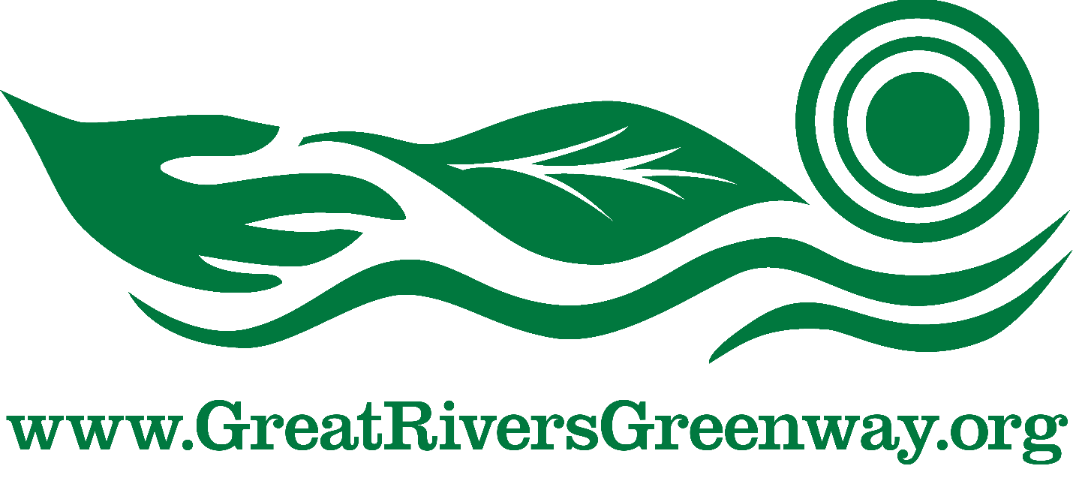

REQUEST FOR PROPOSALS

TO PURCHASE the LACLEDE POWER BUILDING Properties
AT 1245 – 1251, 1246 & 1300 Lewis St.
IN THE NEAR NORTH RIVERFRONT NEIGHBORHOOD

ISSUED BY:
GREAT RIVERS GREENWAY
ISSUED: July 12, 2021
RESPONSE DEADLINE: August 10, 2021
.pdf submittals to www.greatriversgreenway.org/jobs

Contents

1.0 Introduction 3
2.0 The District 4
3.0 The North Riverfront Open Space and Redevelopment Plan 4
4.0 The Properties 4
5.0 Respondent Commitments 4
6.0 Required Contents of Any Proposal 11
7.0 Required Form of the Proposal 11
8.0 Selection Process and Criteria 12
9.0 Questions Regarding This RFP 13
10.0 General Conditions for Submission of Proposal 14

1.0 Introduction

The Metropolitan Park and Recreation District (the “District” or “Great Rivers Greenway”) is issuing this Request for Proposals (“RFP”) seeking proposals (“Proposals”) to purchase the properties at 1245 – 1251, 1246 and 1300 Lewis Street (the “Properties”). The 1245 – 1251 Lewis Street site contains .23 acres. Included at 1246 – 1300 Lewis Street is the historic Laclede Power Building which currently consists of a vacant building containing 18,241 square feet of above grade structure on two sites containing about .66 acres. The building was formerly used as an electrical switching substation from 1904 through the late 1970’s, but it has been vacant since. The District desires that the building and its adjacent properties are redeveloped in a way that brings new life to this part of the St. Louis Riverfront. It is also important that access to and protection of the North Riverfront Trail on the Mississippi Greenway is prioritized.

The intention of this RFP is to solicit proposals from purchasers (“Respondents”) that will contract to purchase the Properties according to provisions, terms, and conditions determined by the District, some of which are contained herein. Other terms and conditions may be developed in response to specific proposals and incorporated into a future agreement. Any contract or agreement resulting from this RFP must be approved by the District’s Board of Directors.

The District, in collaboration with public and private stakeholders in the North Riverfront area, prefer a proposal which considers the North Riverfront Open Space and Redevelopment Plan (the “Plan”) (located at https://greatriversgreenway.org/north-riverfront-open-space-and-redevelopment-plan/) and protects and/or enhances the Riverfront Trail and the North Riverfront area in general. The District will require easements located on the Properties providing access to the Riverfront Trail located on such terms and conditions determined by the District in its reasonable discretion. It is strongly preferred that the Laclede Building not be demolished and that any proposal seeks to preserve and maintain its architectural form.

Preferred redevelopment uses for the Properties include, but are limited to: infrastructure improvements benefitting the community, housing, cultural use, retail housing and mixed use. Proposals demonstrating benefit to the community, job creation and/or uses consistent with the North Riverfront Plan may also be given preference. The District prefers that any proposed redevelopment be completed within five (5) years of the acquisition of the Properties

Proposals should also address the intended uses for the Properties, a summary of the outcomes of the short-term and long-term benefits of the proposed redevelopment of the Properties (including compliance with the Plan), the proposed project timeline, and the financial capacity of the Respondent.

This solicitation may remain open until a Respondent is selected or it is withdrawn.

2.0 The District

The District is a regional public agency serving the City of St. Louis, St. Louis County and St. Charles County. The District connects the St. Louis region with greenways, making it a vibrant place to live, work, and play. Through this effort, the District works to provide active transportation alternatives, preserve nature, improve health and increase the economic vitality of the St. Louis region. More information on the District can be found online at http://greatriversgreenway.org/

3.0 The North Riverfront Open Space and Redevelopment Plan

In late 2015, a collaboration of institutions and individuals published The North Riverfront Open Space and Redevelopment Plan. The Plan describes a comprehensive redevelopment strategy envisioned to revitalize the riverfront to build on the success of the CityArchRiver investment. The Plan recommends the extension of open space to create stronger connections to the river and adjacent communities and identifies existing historic structures including the Laclede Power Building, among others, to represent the authenticity and energy of the area’s industrial past. The Plan was adopted by the City of St. Louis Planning Commission as well as the District’s Board of Directors.

It is the District’s intent to sell the Properties to a purchaser who will utilize the area in a manner that is consistent with the North Riverfront Open Space and Redevelopment Plan and that access to and protection of or improvement to the North Riverfront Trail of the Mississippi Greenway be addressed.

4.0 The Properties

The Properties being offered for sale include 1245 – 1251, 1246 and 1300 Lewis Street. The 3 parcels total .89 acres and include the historic Laclede Power Building, which is now vacant. The City of St. Louis has zoned the properties K - unrestricted.

District staff will be on site on July 27, 2021 from 9 am to 10 am for Respondents to view the property and building.

A map of properties and a photo of the building are below.

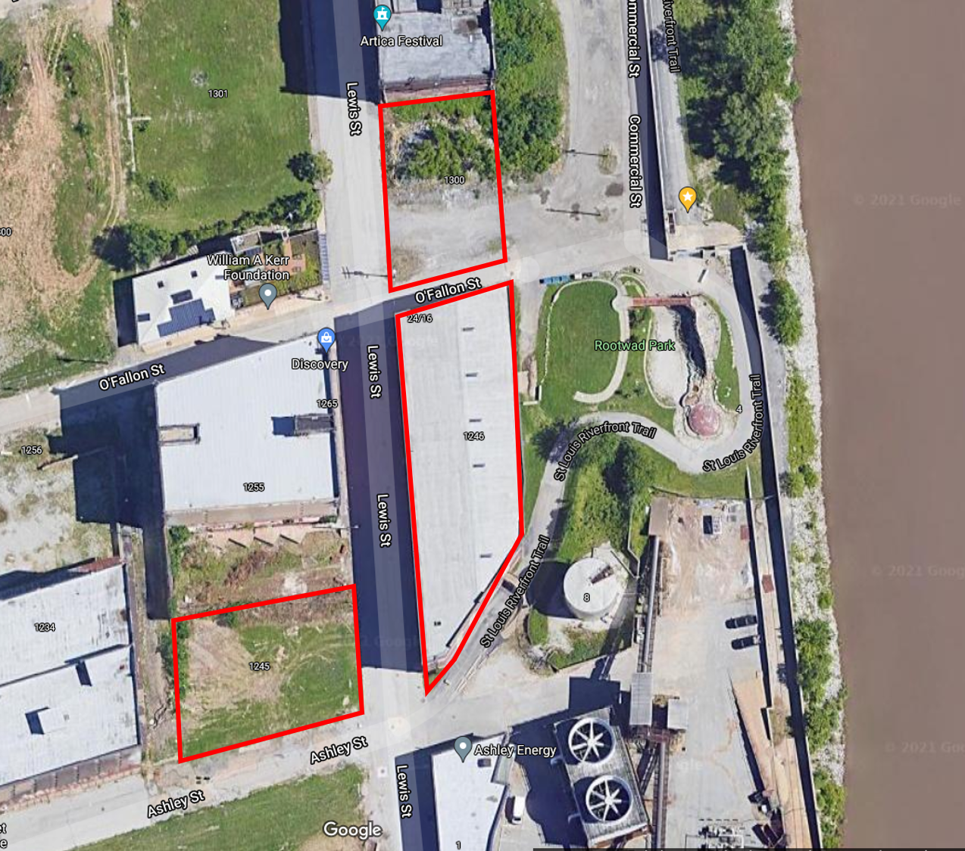

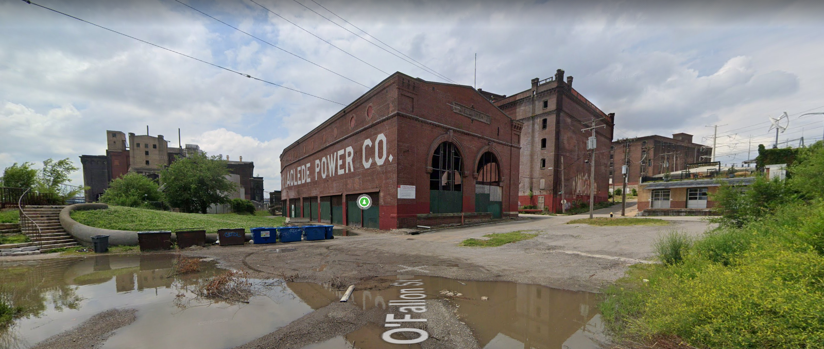

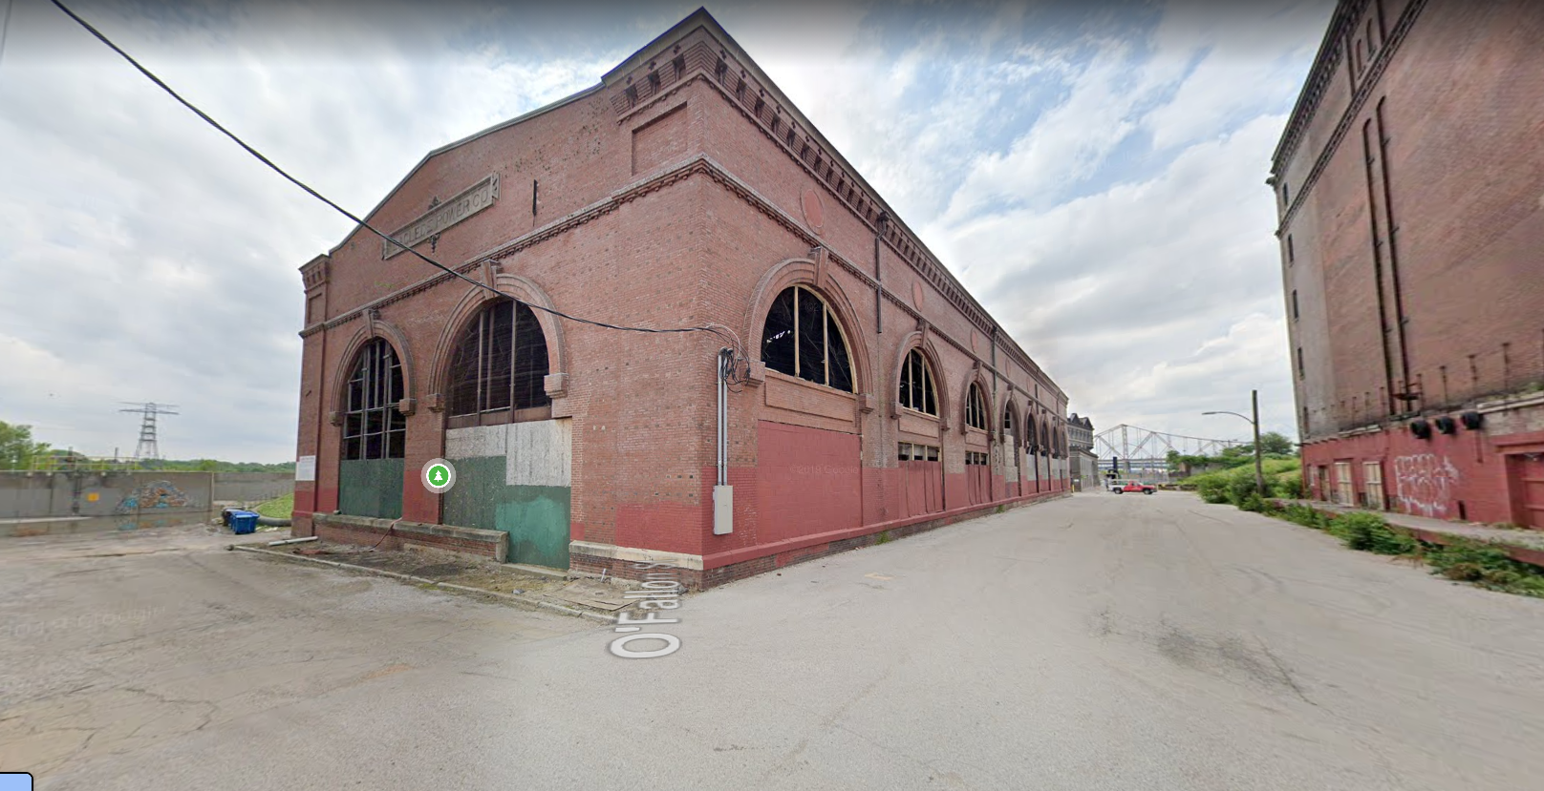

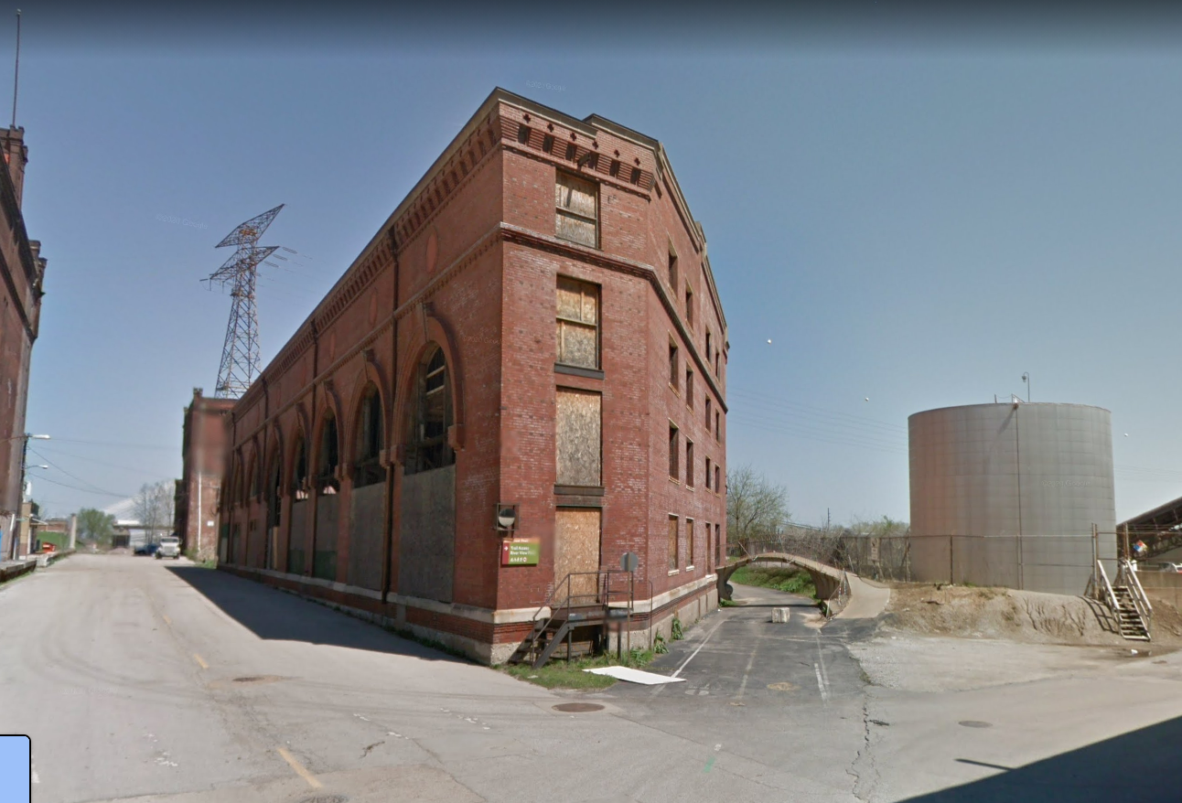
- Respondent Commitments
Each Respondent must affirmatively state the following in its Proposal:

    - Respondent will enter into a contract to purchase or option to purchase the properties at 1245 – 1251, 1246 and 1300 Lewis Street from the Metropolitan Park and Recreation District on terms acceptable to the District; and
    - Respondent agrees to pay and be responsible for all fees, if any, of the State of Missouri, City of St. Louis, or any state or city agency or board required in connection with the Proposal.
    - Respondent agrees to utilize the Properties in a manner that is not in conflict with the North Riverfront Open Space and Redevelopment Plan and that access to and protection of the North Riverfront Trail be addressed.
    - Respondent agrees with the following use restrictions: unlawful sale of drugs, a pawn shop, a title loan company, a payday loan company, a tattoo parlor. The District reserves the right to impose additional use restrictions as determined by the District in its reasonable discretion.

6.0 Required Contents of Any Proposal

Each Respondent must provide, at a minimum, the following information:

- Primary contact information (name, phone, address, email) for the Respondent; and
- Confirmation that the Respondent will purchase the Property (based on the specific intentions of the respondent) and an understanding that, prior to final approval, the Respondent will be required to provide a statement of financial capacity to acquire the property and complete the improvements; and
- A brief summary (no more than one page) of intended use for the Property, including the Laclede Power Building structure, highlighting how it is consistent with the North Riverfront Redevelopment Plan and incorporates the District’s preferences noted in Section 1.0; and
- Affirmative statement agreeing with Respondent Commitments from Section 5.0; and
- A narrative of the proposed improvements and investments in the Property; and
- Description of Respondent’s team and experience with similar projects. Please include details related to the type of project(s), project size(s), timeline(s), and costs.
- Proposed purchase price; and
- Any proposed closing contingencies or other terms and conditions required by the Respondent for the acquisition of the Properties.

7.0 Required Form of the Proposal

- All proposals must be clearly marked “Response to Request to Purchase Laclede Power Building Properties”; and
- All Proposals must be complete and include all of the information requested in Section 6.0 of this RFP; and
- All Proposals must be delivered electronically in .pdf form to www.greatriversgreenway.org/jobs and must clearly identify the respondent (including primary contact information) in the submission, which may be released by the District as public information upon receipt of the proposal ; and

NOTE: The District COMPLIES WITH MISSOURI’S “SUNSHINE LAW” (CHAPTER 610 RSMO.). WHILE PROPOSALS MAY BE WITHHELD FROM PUBLIC DISCLOSURE UNDER THE “REAL ESTATE NEGOTIATIONS” EXEMPTION (SECTION 610.021(2) RSMO.) OR THE SEALED PROPOSAL EXCEPTION (SECTION 610.021(12) RSMO.) DURING THE EVALUATION PROCESS, ALL PROPOSAL MATERIALS MAY BECOME PUBLIC INFORMATION AT THE CONCLUSION OF THE PROCESS. FURTHER, THE DISTRICT CANNOT GUARANTEE CONFIDENTIALITY OF ANY MATERIALS DURING THE EVALUATION PROCESS IN THE EVENT OF A LEGAL CHALLENGE. THUS, PROPOSALS AND COMMUNICATIONS EXCHANGED IN RESPONSE TO THIS RFP SHOULD BE ASSUMED TO BE POTENTIALLY SUBJECT TO PUBLIC DISCLOSURE. THE DISRICT, ACTING IN ITS SOLE, UNRESTRICTED DISCRETION, SHALL DETERMINE THE STRINGENCY AND/OR STRIDENCY WITH WHICH IT WILL OPPOSE, IF AT ALL, LEGAL CHALLENGES TO NONDISCLOSURE OF FINANCIAL OR OTHER INFORMATION INCLUDED IN RESPONSES.

8.0 Selection Process and Criteria

Responses will be reviewed and evaluated by the District, with potential input from North Riverfront stakeholders on the basis of: compliance with RFP requirements, price, perceived ability of Respondent to meet obligations (subject to financial capacity disclosure prior to final approval), impacts on the area and intended use. The District and other stakeholders may request interviews with one or more Respondents. The selected Proposal will be brought to the Great Rivers Greenway Board of Directors for consideration and approval.

9.0 Questions Regarding This RFP
Any and all questions or requests for clarification with respect to this RFP or additional information about the site and facility must be submitted by 3 pm on July 29, 2021 to the GRG website.

10.0 General Conditions for Submission of Proposal
The District reserves the right to reject any or all Proposals for any reason whatsoever; to select one or more Respondents; to void or reissue this RFP, to terminate the review process and/or terminate negotiations at any time; to revise any conditions and stipulations contained herein, as convenient, desirable or necessary; to further negotiate fees, rates and financial arrangements, etc; to establish further criteria for selection; to ask Respondents to submit additional information or evidence of their qualifications and experience; to waive informalities in the proposals and in the proposal process; to negotiate with successful Respondents; all in the District’s sole discretion. Through submittal, the Respondent is indicating that all information provided is true and correct. The District is not responsible for any cost incurred by any Respondent in the submission of its Proposal or in taking any action thereafter.

